CPE 381 Project Phase 2

1. Problem Description and Solution
Phase 2 of the project attempts to undo the work of Phase 1, by removing the 2500 Hz sine wave from the wav file generated in Phase 1.
In order to do this, a finite response low pass filter was designed which cuts off frequencies in the upper ranges of the signal, removing the sine wave entirely, and can run in real time. In addition, a much higher quality, but not real time, band stop finite response filter was designed to cut out a narrow range around 2500 Hz to provide a cleaner signal. A C++ program was then written which can be configured in the source code to use any finite response filter and apply it to an input wav file. This program was configured to use the two filters described earlier, based on user input.

2. Filter Design

Low Pass
The low pass filter used had the following characteristics:
- Finite impulse response
- Sampling frequency: 44100 Hertz and 22050 Hertz
- Pass Frequency (below this): 2300 Hertz
- Stop Frequency: 2500 Hertz
- Attenuation of pass band: 1 decibel
- Attenuation of stop band: 60 decibel
- Number of Coefficients: 437 (44100), 219 (22050)
Plots of its magnitude and phase response for both 44100 and 22050 Hertz sampling frequencies are in the Appendix, Figures 1 – 4.

Resulting Sound Quality
It is clear that the resulting file has lost much of its high frequencies, as the sound is less “crisp” than the original. However, the speech which begins the recording is perfectly audible, and the music is still very recognizable.

Design Choices
A finite impulse response filter was chosen for two reasons. The first and foremost is the fact that every finite impulse filter will be stable, meaning that code written to handle a finite response filter can be used for any filter, without concern to the stability of the filter itself. This increases the potential reusabliity of the code. The second reasons was simplicity to implement. Given that a finite response filter uses fewer buffers, it is easier to implement, and thus more likely to be successfully completed when working in a time-limited situation.
A low pass filter was used here because it required few coefficients, but retained most of the frequencies which the human ear can detected, despite removing the 2500 Hertz sine wave. The result of using fewer coefficients is that the program can run faster when using this filter.

Filter Coefficients
The filter coefficients are contained in the Appendix for both 44100 Hertz and 22050 Hertz in Listings 1 and 2 respectively. Additionally, they can be found in the folder Filters, lowPassCoarse.h (44100 Hz) and lowPassCoarse22k.h. In these header files, the types have been converted to double, from the Matlab specific one. This works since the Matlab types header mapped this type onto a double, and additionally provides a greater degree of flexibility for where the software can be compiled, as it no longer requires the Matlab types C header.

Band Stop
In order to provide a reference point to compare the low pass filter against, a high quality band stop filter was created as well. This filter resulted in audio apparently indistinguishable from the original audio, at the cost of being much slower to apply. It had the following characteristics:
- Finite impulse response
- Sampling Frequency: 44100 Hertz and 22050 Hertz
- Pass Frequency 1: 2450 Hertz
- Stop Frequency 1: 2475 Hertz
- Stop Frequency 2: 2525
- Pass Frequency 2: 2550
- Attenuation of pass band 1: 0.5 decibel (default – seemed to work well)
- Attenuation of pass band 2: 1 decibel
- Attenuation of stop band: 60 decibel
- Number of Coefficients: 4093 (44100), 2047 (22050)
Plots of its magnitude and phase response for only 44100 Hertz sampling frequency are included in the Appendix, Figures 5 and 6.

Design Choices
The reasons for choosing a finite impulse response filter have already been described.
A band stop filter was added to the design in order to provide a filter which after being applied would create audio which sounded nearly as good as the original audio (before the sine wave was added). The major downside was that it takes much longer to run than the low pass filter, however in the context of music (since much of the audio was music), having a slow – even non-real time – filter could be a good choice, as quality often matters more than speed in audio.

Filter Coefficients
Since the band stop filter was done only to provide a point of reference to the low pass filter, and was not part of the requriements, the coefficients are only provided on the online copy rather than included in the Appendix. They can be found in the Filters directory, as bandStopFine.h and bandStopFine22k.h.
Much like in the low pass filter, the type was converted from the Matlab type to a double.

Organization of Processing
A description of how the C++ code handles the processing of the filter can be broken down into a few major steps.

1. Getting and Handling User Input
The first stage of processing the filter is to receive the user input. The user input includes the input file first, then the filename to output, then (optionally) a flag 'h' to tell the program to apply the band stop filter rather than the low pass filter that is applied by default.
In this stage, the inputs are checked. First the number of arguments are validated, then the program attempts to open the files specified. Next it checks that the file is 16-bit sample size. Finally it checks that the sampling rate is either 44100 or 22050, erroring out for other rates.
Finally based on the optional flag and the sampling size, which filter to apply is chosen. In this stage also, the header is read in, and the new file's header is written out. Additionally, a timer is started to keep track of the time.

2. Getting Samples, Filtering and Saving
In this stage, the actual work is done. For all the samples in the wav file, each sample is read into an array of shorts equal to the number of channels. Then each sample is split into the competent samples (making up each channel) and placed in a buffer for the given channel. This is done with an array of arrays, with each component array making up a channel. Each new sample is placed at the start of the array array it is stored in.
Each of these channel arrays are individually passed to the filterSample function, which applies the filter by multiplying each sample in the array by the sample at the same index, and adding the result to an accumulator variable. All of this work is done in double, to maintain the desired precision. The resulting value is cast to a short, and returned to the calling function. Additionally, this function shifts the samples to the right to prepare for the next sample.
Once all the channels for the current sample have been filtered, the function then writes the resulting sample to the output file.

3. Calculating Time
Finally, the timer is stopped, and the total processing time is calculated, and displayed with other data to the user in a Summary.txt file.

3. Spectrum of files
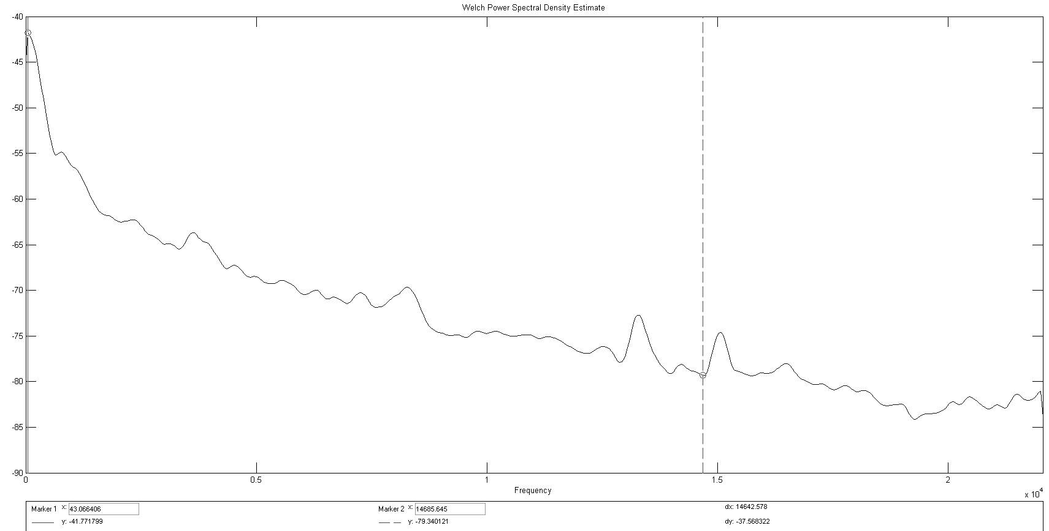Original File - Before Sine Wave – Amplitude in Decibels

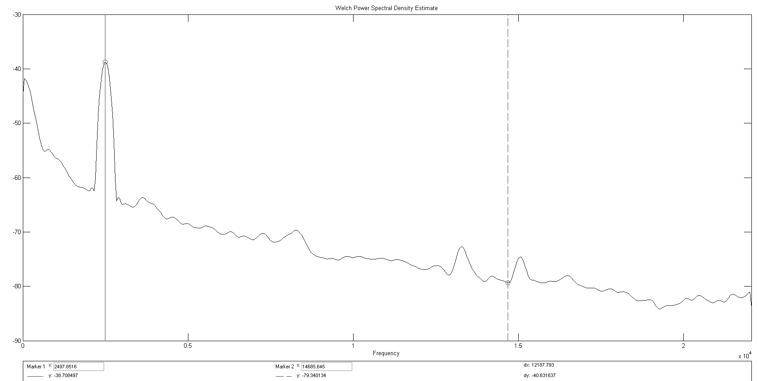Spectrum after Sine Wave added - notice that the peak is at approximately 2500 Hertz
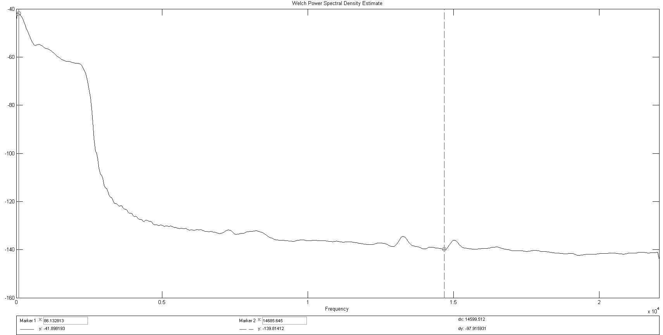Spectrum filtered using Low Pass - notice how much the higher frequencies are attenuated

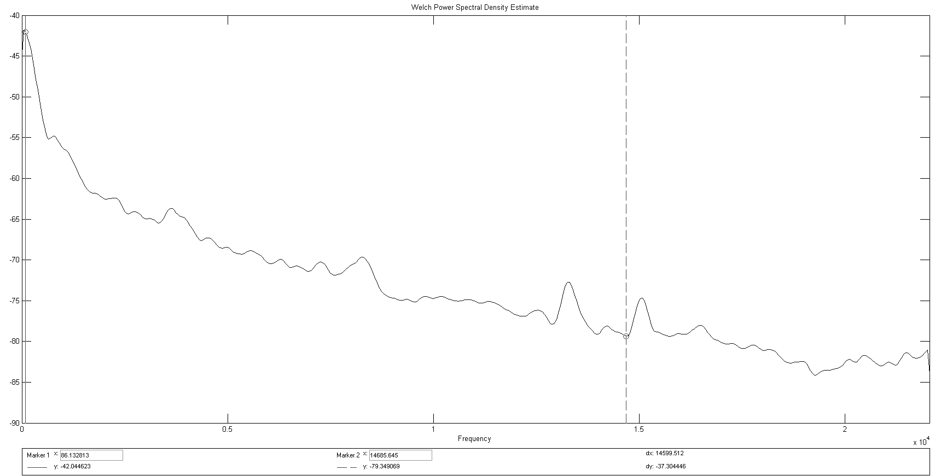Spectrum after Band Pass filter applied - notice how it looks almost exactly like the origanl spectrum

